# File permissions in Linux

## Project description

Update file and folder permissions for the projects folder to reflect the organizations permission and access standards for the folder.

## Check file and directory details

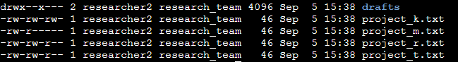

## Describe the permissions string

A 10-character string begins each entry and indicates how the permissions on the file are set. For instance, a directory with full permissions for all owner types would be drwxrwxrwx:

The 1st character indicates the file type. The d indicates it’s a directory. When this character is a hyphen (-), it's a regular file.

The 2nd-4th characters indicate the read (r), write (w), and execute (x) permissions for the user. When one of these characters is a hyphen (-) instead, it indicates that this permission is not granted to the user.

The 5th-7th characters indicate the read (r), write (w), and execute (x) permissions for the group. When one of these characters is a hyphen (-) instead, it indicates that this permission is not granted for the group.

The 8th-10th characters indicate the read (r), write (w), and execute (x) permissions for the owner type of other. This owner type consists of all other users on the system apart from the user and the group. When one of these characters is a hyphen (-) instead, that indicates that this permission is not granted for other.

## Change file permissions

The organization does not allow others to have write access to any files. Modify the file permissions to reflect the correct access for the organization.

Commands used to change file permissions

chmod o-w project_k.txt - removed write permissions from the other role

chmod g-r project_m.txt - added read permissions to the group role

Commands used to view the file permissions

ls -l

## Change file permissions on a hidden file

The research team has archived .project_x.txt, which is why it’s a hidden file. This file should not have write permissions for anyone, but the user and group should be able to read the file. Use a Linux command to assign .project_x.txt the appropriate authorization.

Command used to change the hidden file permissions

chmod u-w,g-w,g+r .project_x.txt removed write from the user and group roles. Added read to group role.

Commands used to view the hidden file permissions

ls -la

## Change directory permissions

Only **researcher2** should be allowed to access the **drafts** directory and its contents. Modify the folder permissions to reflect the correct access for the organization.

Command used to update the directory permission

chmod g-x drafts – removed execute permission from the group role

Commands used to view the folder permissions

ls -l

## Summary

The file and folder permissions for the project folder have been updated to reflect the organizations standards for the folder and it contents.